- Initial design description – Procedural decomposition
- The program would first prompt the user to input an image filename in the console, then use Scanner to read said filename and open the matching image file accordingly.
- The user would be asked to input another filename if the program cannot find or open their previous request.
- Next, the program would also use Scanner to read in the user’s requested filter name (Sepia, Temperature Tint, Channel Isolator, Posterization, or Duotone) from the console and store it for later method parameters.
- If the filter name isn’t among the predetermined set, the user would be prompted to input another filter name.
- Next, the image would be converted into a 2D array based on its pixels; to contain the color values, each pixel can be filled by another mini array.
- Next, the program would convert the input image into a 2D array based on the arrangement of its pixels, representing each pixel by its combined RGB color values.
- Next, a specific method determined from the user’s requested filter name would be called on to alter the colors in the 2D array. This method should adjust each RGB value in the array according to the specified filter’s color transformations, as well as keeping them within the 255 limit.
- Next, the method would convert the modified 2D array back into standard image format without corrupting the file and return it to main.
- Then, the main function should save the newly-filtered image locally in the same format as the input.
- Finally, the main function would print a confirmation message in the console to note that the file has been saved.
- Evidence(s) of thinking ahead – Flowchart
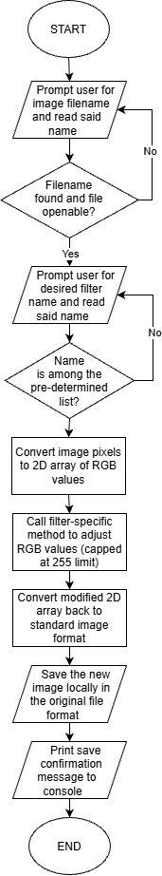
- Rationale why this should work
- Processing the image as a 2D array allows for individual pixels to be directly mathematically manipulated through indexing and traversal, which should make it computationally efficient enough to meet the 3-second processing goal for images up to 1920x1080 pixels.
- By separating the entire program into File I/O handling and methods for each filter, the system should be able to safely handle RGB calculations to preventing overflow that may cause image corruption when converting back to image format.
- The error handling sections for missing files and filters should prevent the program from crashing.
- Detailed test plan
Test Case | Input | Expected Output
Standard | file: "man.jpg"  filter: "Sepia" | Modified "man.jpg" saves locally, success message prints
Performance | 1920x1080 px image file  filter: "Posterization" | Applies filter and saves image in < 3 seconds
Max/min RGB | Image containing pure white (255, 255, 255) and pure black (0, 0, 0)  Any valid filter | Filter applied without method crashing from overflow, image converts back correctly
File not found | file: "missing.jpg" (missing file) | User is re-prompted for a new filename
Filter not found | Any valid image  filter: "BlackAndWhite" (not a valid option) | User is re-prompted to input a valid filter type

